Driffield Youth Action
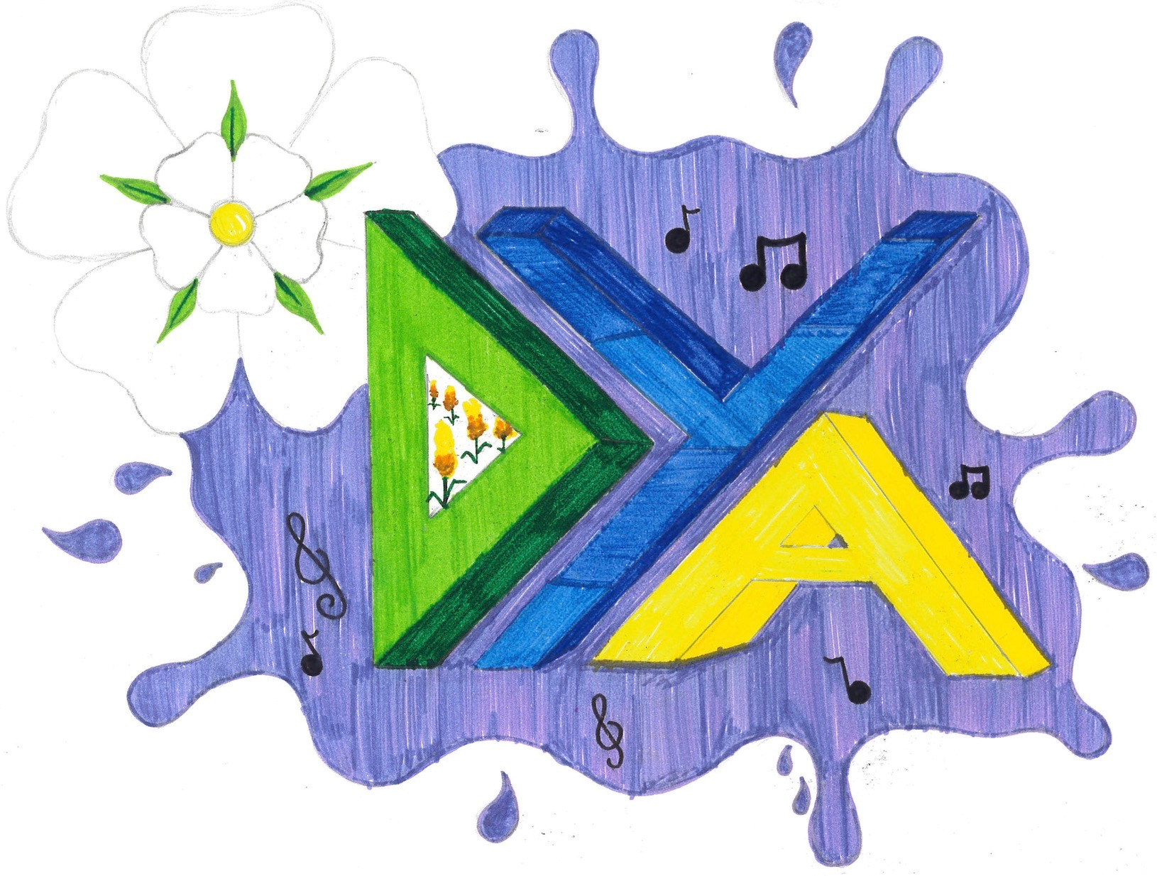
Registration Form
Please complete all sections in black ink.
All information supplied will be held in strict confidence.

This form must be signed by both parent/guardian and the young person if under 18 years.
Project Rules: by joining in the project you agree to the following rules:
I will
1. Show respect for the building /grounds/equipment/ staff and volunteers at all times.
2. Not swear/shout/fight/bully/name call or carry out any other type of anti-social behaviour.
3. Be welcoming to new people.
4. Put all litter in the bins provided.
I will not
4. Bring drugs or alcohol or energy drinks into the building and grounds.
5. Cause damage to the building/grounds/equipment or neighbourhood.
6. Break the law or behave in a way that could upset other people and/or give the project a bad name.
7. Smoke or use e-cigs on site, or anywhere on Scotchburn Garth.
8. Enter out of bounds areas, including container park, or leave the site without permission/signing out

These expectations are for the protection and benefit of all users.

I (young person) _______________________________________________ agree to the rules of the Youth Project

Name...................................................................... Signed............................................. Date.........................

Parent/Guardian’s Section
1. Child/Young Person’s details

Young Persons Birth Name…………………………………………. Surname…………………………………….

Preferred name if different to birth name …………………………………………………..

Date of Birth………………………………. Preferred pronoun He She They

2. Parent/Guardian’s details

Title e.g. Mrs/Mr………….. Forename………………………………… Surname………………………………….

Address………………………………………………………………………………………………………………………………………

……………………………………………………………………………………………… Postcode………………………………..

Tel No………………………………….. Mobile……………………………… Email……………………………………….

Relationship to Child/Young Person………………………………………………………….

Does your yp receive free school meals Yes/No

Medical Details For safety reasons all participants with DYA must provide information of any disability or medical condition prior to joining. Any changes must be notified in writing.

1. Name of GP........................................ Surgery........................................................... Tel No.................................

2. Does your child suffer from any medical conditions or allergies? Yes/No

If YES, please give details...................................................................................................................................................

...........................................................................................................................................................................................

3.Will your child be bringing medication to the Youth sessions? Yes/No

If YES, please give details...................................................................................................................................................

...........................................................................................................................................................................................

4.Does your child have any disabilities/learning difficulties? Yes/No

If YES, please give details...................................................................................................................................................

...........................................................................................................................................................................................

The personal data you have supplied on this form will be kept in compliance with the Data Protection Act 1998. Your information will be used to administer your child’s participation in the Youth Project activities and for the purposes described above, and will not be disclosed to anyone except where impersonal statistical data may be derived from your data and used for management analysis. If your young person does not attend for a period of 6 months their details be removed from our database.

For any query please contact the Youth Workers on 07555 298304 or email Info@dya.org.uk

DECLARATION BY PARENT/GUARDIAN

Please delete any items that you do not consent to

1. I am the parent/ guardian of the child named above and I give consent for him/her to attend activities organised by DYA, based primarily at Scotchburn Garth, Skerne Road, Driffield, YO25 6EF.

2. I give consent for my child to be taken for treatment in the event of an emergency.

3. I agree that photos/videos can be taken of my child participating in the youth project activities in order to publicise the group’s activities.

4. I understand that I am responsible for ensuring my child is brought to and collected from the youth project sessions or I allow my child to make his/her own way to and from the sessions.

5. I acknowledge the need for my child to behave responsibly at all times and to follow the rules of DYA.

Name…………………………………………………………….

Signature………………………………………………………. Date…………………………………….

